Qlik2DataRobot

Installation Guide

Integrate Qlik with DataRobot

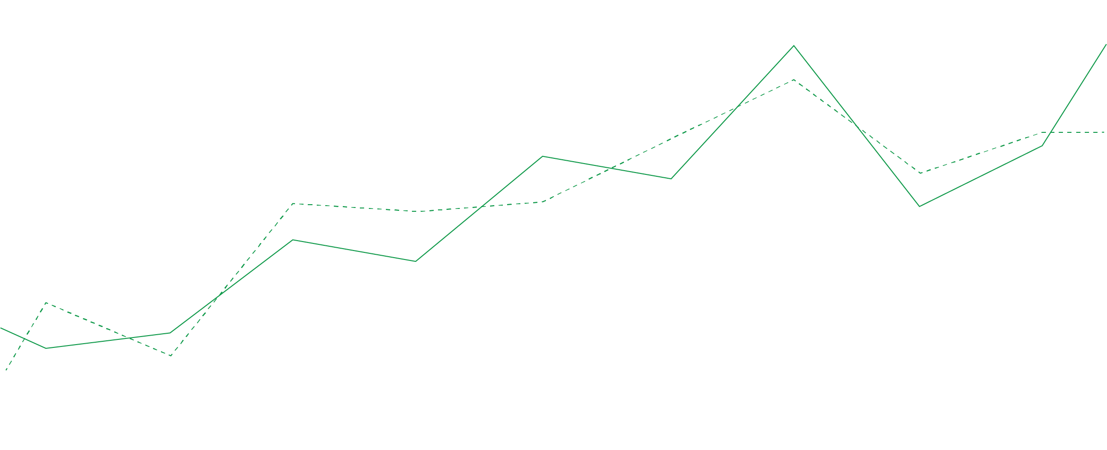

TABLE OF CONTENTS

What’s required to get started? 2

Download the extensions 2

Qlik2DataRobot (Server Side Extension) 3

Installing Qlik2DataRobot on Windows 3

Configuring Qlik Sense Desktop 6

Configuring Qlik Sense Enterprise on Windows 7

Qlik2DataRobot (Client Extension) 9

Installing on Qlik Sense Desktop 9

Installing on Qlik Sense Enterprise on Windows 9

Using Qlik2DataRobot 10

Sending data to DataRobot from Qlik Sense 10

Consuming a published DataRobot Deployment 14

Appendix 1: Connector Specification 17

Supported Request Types 17

### Document Information

This document is maintained with each version of the software, for the latest version visit: <https://github.com/AnalyticsEarth/Qlik2DataRobot/tree/master/docs>

Author:  
Steven Pressland, Principal Solution Architect, Qlik

**Version Date:**  
13 September 2019

What’s required to get started?

Before you can start integrating Qlik Sense and DataRobot you need to have the following components in place:

* Qlik Sense; this can either be the free Desktop edition which can be downloaded with a QlikID from qlik.com (a great way to get started and test the integration), or using Qlik Sense Enterprise.
* DataRobot; users will need an API key, which can be found on the account profile page within DataRobot.
* Connectivity from the Qlik2DataRobot application to both Qlik Sense and DataRobot. DataRobot typically runs against an internet facing URL and therefore the appropriate network access must be available to ensure server to server communication.

Download the extensions

Download the two installation packages required for installation on Windows and pick a location for the server side extension to be run, if not already downloaded to that machine, transfer **Qlik2DataRobot Windows Installer.msi** to a convenient location on that machine.

* If you are running Qlik Sense Desktop the installation will likely be on the same machine as desktop is running, but does not have to be.
* For Qlik Sense Enterprise you can install on an existing Qlik Sense server, however you are free to install on a separate machine if it is accessible by all Qlik Sense nodes running an engine service.

The Qlik2DataRobot installation files can be found on github (download all components from the releases page):

<https://github.com/AnalyticsEarth/Qlik2DataRobot/releases>

<https://github.com/AnalyticsEarth/Qlik2DataRobot-Ext/releases>

Qlik2DataRobot (Server Side Extension)

The first component to consider is the Server Side Extension, which will be configured as an Analytic Connector within Qlik Sense. This provides the link between the Qlik associative engine and DataRobot.

# Installing Qlik2DataRobot on Windows

Installing on Windows is straightforward and achieved through an installation wizard package which will install and configure the application.

1. Run **Qlik2DataRobot Windows Installer.msi**

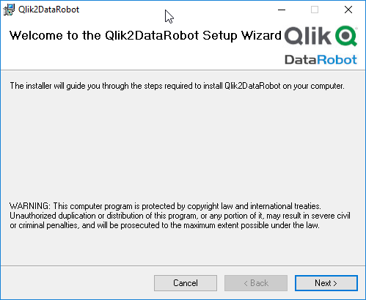

1. Click **Next**

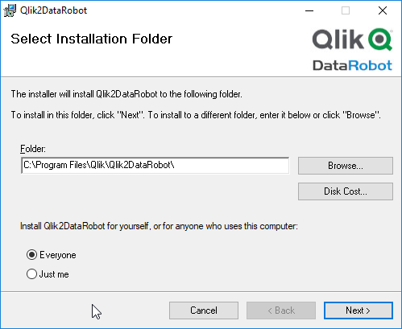

1. Confirm the location you wish to install at click **Next**

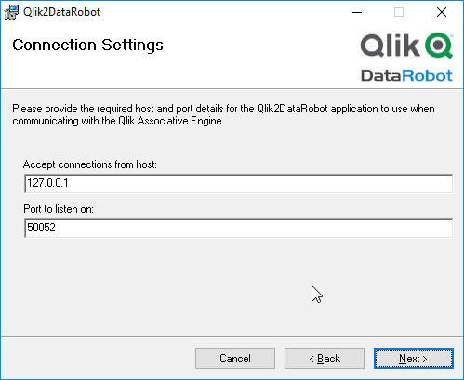

1. Update the connection settings required:
   1. The default settings will only allow connections coming from the local machine, if you are running on a different machine to the Qlik Associative Engine, the host setting will need to change. To allow connections from multiples sites or engines, use **0.0.0.0**.
   2. The port is arbitrary, however if you already have a connector listening on this port, you will need to set a new one.
   3. These settings can be changed post installation by editing a configuration file.
   4. Click **Next**

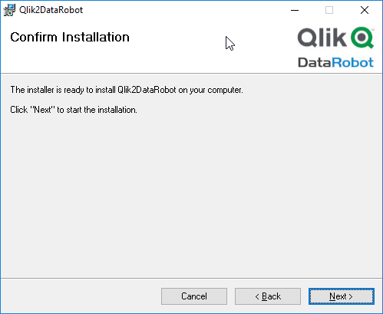

1. Click **Next**

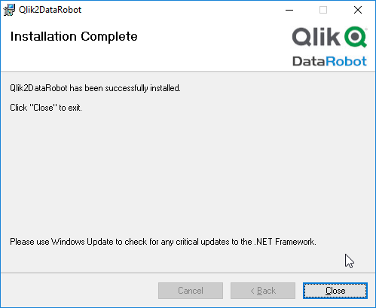

1. Once installation has completed, click **Close**

You may get an installation error, this usually means that your machine does not have a compatible version of .NET framework. To get the latest version, visit <https://dotnet.microsoft.com/download/dotnet-framework>

1. Version 2+ of Qlik2DataRobot installs as a service and this will automatically start. However you may want to manually run the connector, in which case you need to stop the windows service (and change its startup behavior if you want this to not start on boot) and run the Qlik2DataRobot application manually.



1. A new shortcut is provided on the windows application list. Launch the application.

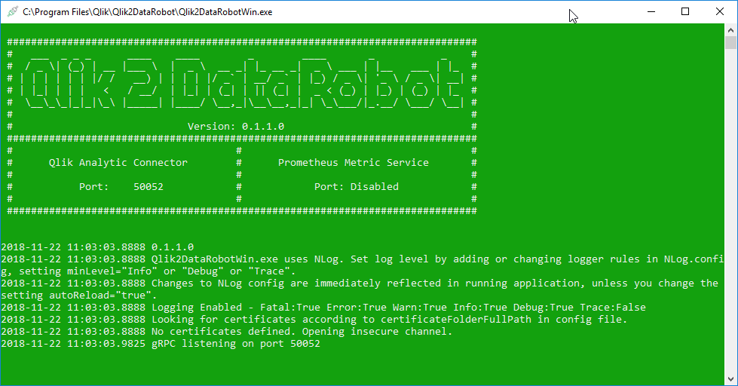

1. Confirm that **Qlik2DataRobot** is running. The application needs to be left open for the connectivity to work (you can minimize the window), however you may prefer to use the windows service if you require a log running background service.
2. Always launch **Qlik2DataRobot** before starting **Qlik Sense** as the connection is made on start up.

# Configuring Qlik Sense Desktop

Configuration of **Qlik Sense Desktop** is done using the **Settings.ini** file located at:

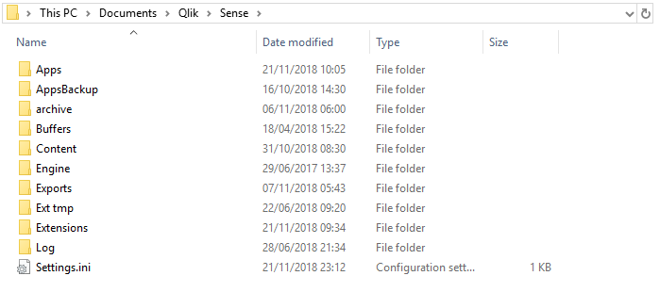

1. Open this file (or create one if it does not exist).



1. Within the **[Settings 7]** section add a **SSEPlugin** line:

SSEPlugin=DataRobot,localhost:50052,,20,2000

* 1. If other plugins have been installed, the connection should be appended to the end of the line, delimited with a semi-colon:

SSEPlugin=R,localhost:50051,,2000,2000;DataRobot,localhost:50052,,20,2000

1. Ensure there is a blank line at the end of the text file.
2. Start **Qlik Sense Desktop**, if everything is configured correctly a new log entry should appear in the **Qlik2DataRobot** window.

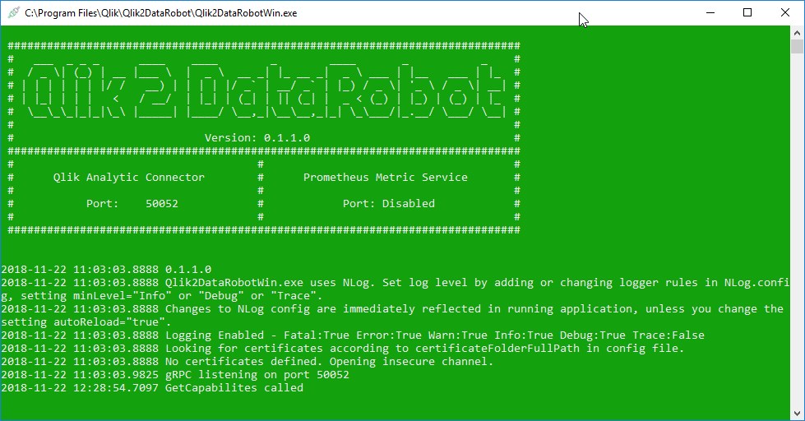

# Configuring Qlik Sense Enterprise on Windows

Configuration of **Qlik Sense Enterprise** is performed through the QMC:

1. Navigate to the QMC for the Qlik Sense site



1. Select **Analytic connections**



1. Click **Create new**

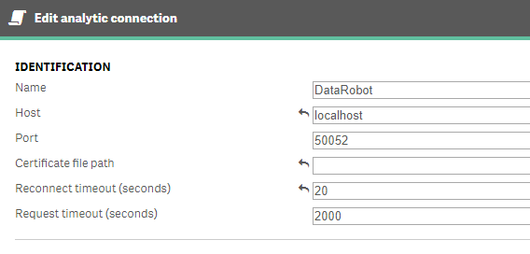

1. Enter the correct details to refer to the host and port you set when configuring the application above.

*The name by default should be called* ***DataRobot****. If you choose to change this, you will need to make additional changes when configuring the client extension and script code snippets.*



1. Click **Apply**
2. All Qlik engines will attempt to connect to Qlik2DataRobot and you should see a ***GetCapabilites*** log item for each request.

# Qlik2DataRobot Log Files

Qlik2DataRobot uses a logging technology called NLog. This will record the output from the connector to either a file or the console. In the event of running as a windows service, it is recommended to use the file logging. The default settings for the connector will save log files to c:\logs\ however you can change this path my changing the NLog.config file located in the installation folder you selected in the install wizard.

## Changing the Log location

Edit the config file and replace the path with the folder of your choice:

<target xsi:type="File" name="file" fileName="c:/logs/${shortdate}.log"

layout="${longdate} ${uppercase:${level}} ${message}" />

## Change the Log Level

By default, the log level is set to Info, for more detailed logs you can specify Debug or Trace.

<logger name="*" minlevel="Info" writeTo="file" />

Qlik2DataRobot (Client Extension)

Qlik Sense client extensions are distributed as .zip files. The client extension for Qlik2DataRobot is called:

* qlik2datarobotext.zip

# Installing on Qlik Sense Desktop

Unzip the contents of the file and copy to the extension folder, by standard located at:

* Documents\Qlik\Sense\Extensions
* The files should be placed in a folder called **qlik2datarobotext**

# Installing on Qlik Sense Enterprise on Windows

Import the zip file using the QMC



1. Click Extensions



1. Click Import

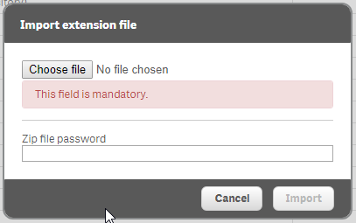

1. Select the zip file and click Import



1. Confirm that the extension is listed in the extension list

Using Qlik2DataRobot

# Sending data to DataRobot from Qlik Sense

Sending data from a Qlik application happens after the app has been loaded. The transfer is configured and triggered by the client extension. The data sent will be limited to that included in selections made by the user. All data transfers happen via the server side extension and no data is sent to or via the client browser.

Add the ***Qlik 2 DataRobot*** extension from the Custom object menu:

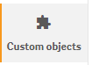

1. Select **Custom objects**



1. Drag **Qlik 2 DataRobot** onto the sheet

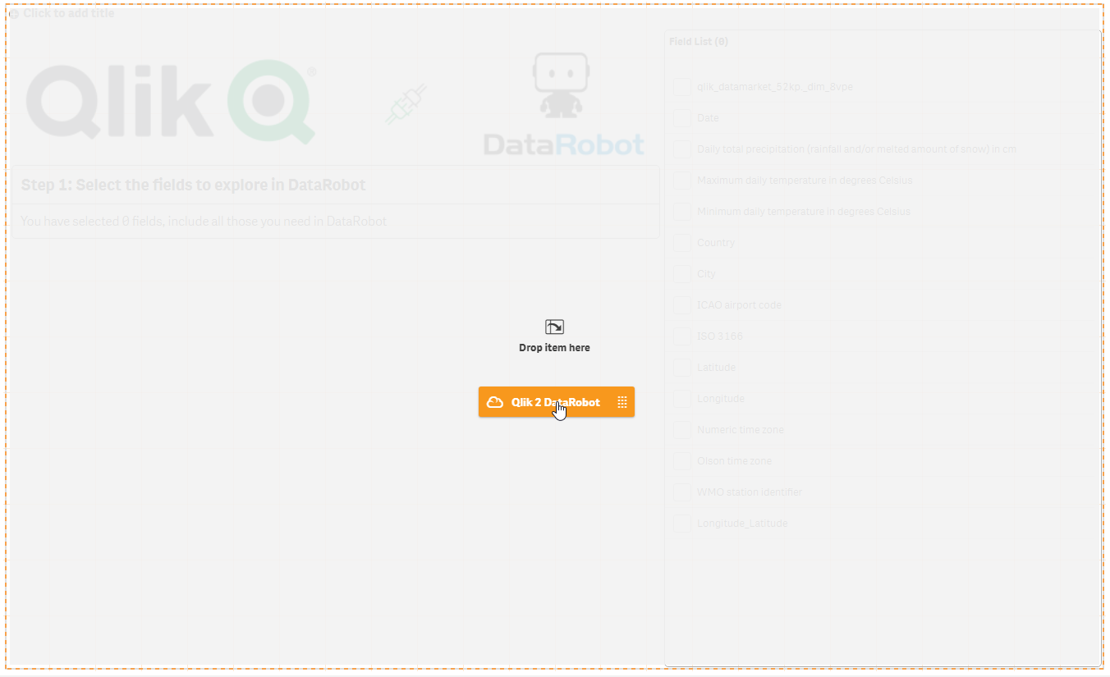

1. Select the extension mode (new for version 2) as “Upload Data”

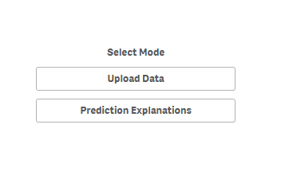

1. Configure the extension:

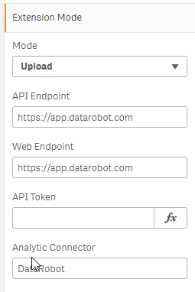

1. Enter your **API Token**, the other endpoints should not need changing, however if you have a different configuration it can be entered here.

*(If you do not enter the API token, you will be prompted to enter it each time when creating a project. This is helpful if the extension is part of a shared application)*



1. Click **Done**

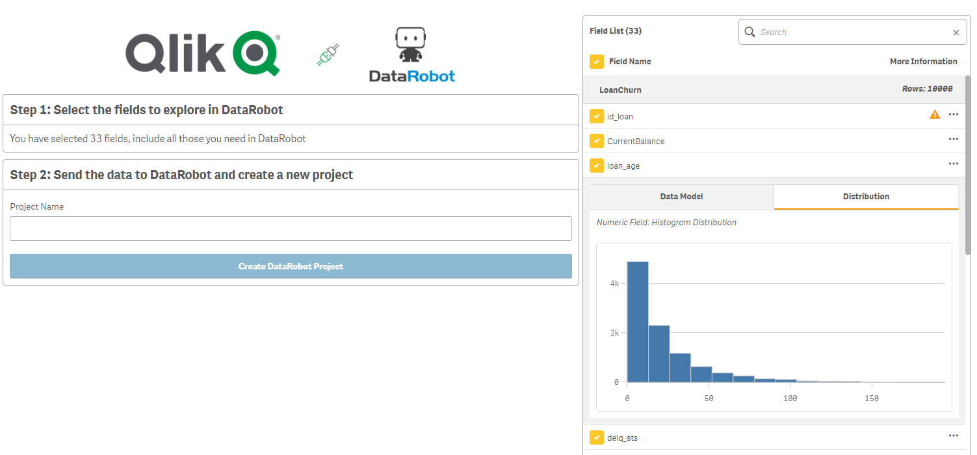

1. Select the fields you wish to send to **DataRobot**

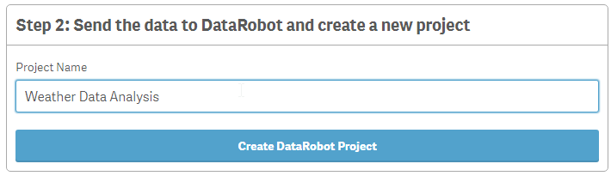

1. Enter the **Project Name** and click **Create DataRobot Project**

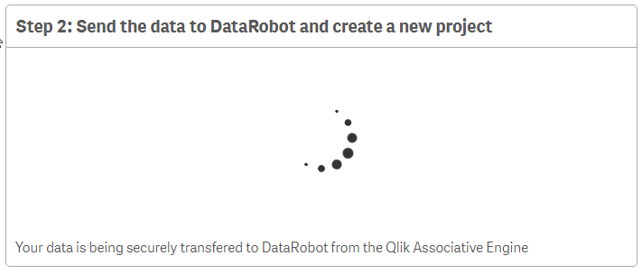

1. Wait for the data to transfer

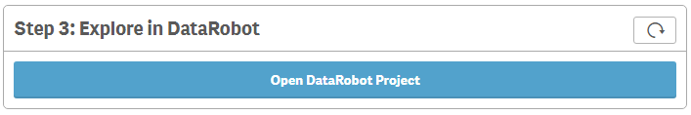

1. Once the data transfer is complete, click **Open DataRobot Project** to launch in a new browser window.

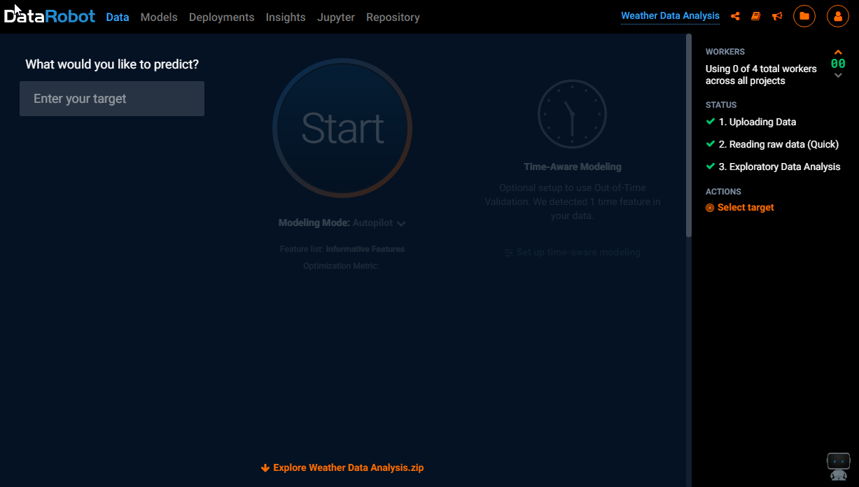

# Consuming a published DataRobot Deployment

Once a deployment has been created within DataRobot this can be used to request a prediction from a Qlik application. The functionality used for this capability does not reply on a Qlik Sense specific extension, therefore is compatible with Qlik Sense, QlikView and Qlik Core.

## Getting the required information from DataRobot

1. Select your deployment

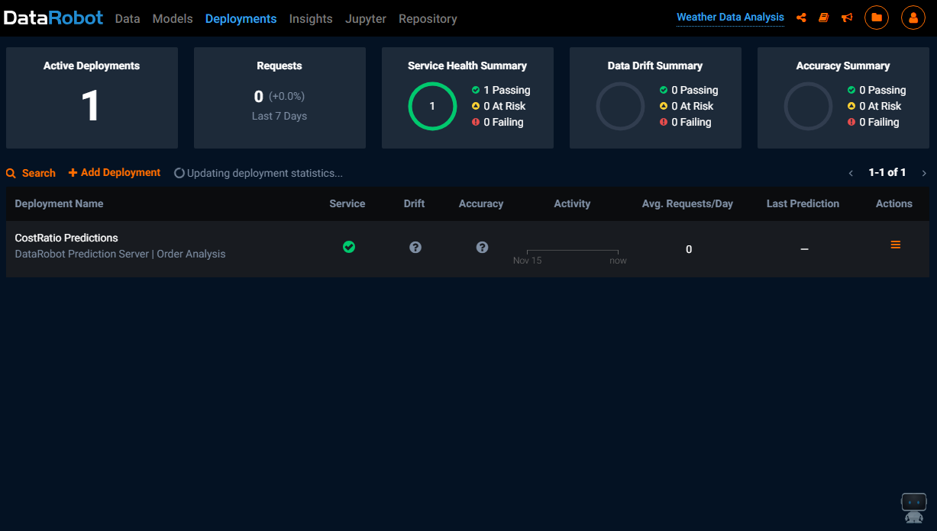

1. Select Integrations

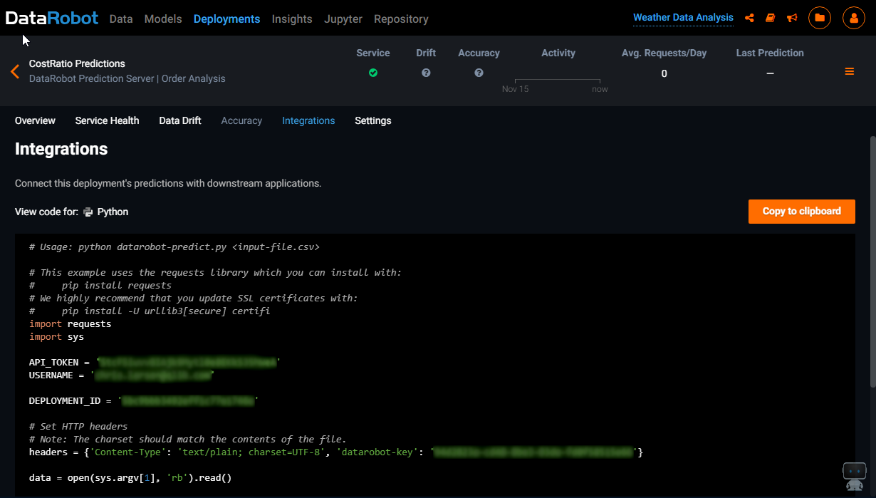

Using the sample Python code, make a note of the following parameters:

* API_TOKEN
* DEPLOYMENT_ID
* datarobot-key

## Creating a Qlik application load script

Ensure all the data needed in DataRobot is in one Qlik table within your script. This may involve transforming your tables using joins for scoring. This table does not have to be used in the finished data model, so can be a temporary asset as required. This document does not cover how to produce this table.

The current version of Qlik2DataRobot requires the requests be made for a block of data no larger than the limit allowed by DataRobot deployments service.

Using a Qlik script loop, the requests can be made in succession and combined back into a single results table. The result table will provide two columns of data, the field supplied in the request marked as the “keyfield” and the prediction value from the DataRobot API.

## Example Script

The example script presumes the data is stored in a table called **LoadStats**

LET vRows = NoOfRows('LoanStats');

SET vBatchSize = 80000; //Set the batch size required

LET vGroups = $(vRows) / $(vBatchSize);

FOR i = 0 TO $(vGroups)

TRACE BATCH $(i);

[BatchData]:

NoConcatenate

LOAD

[RecID],

[loan_amnt],

[term],

[int_rate],

[installment],

[grade],

[sub_grade],

[emp_title],

[emp_length],

[home_ownership],

[annual_inc],

[verification_status],

[issue_d],

[loan_status],

[pymnt_plan],

[purpose],

[title],

[addr_state],

[dti]

RESIDENT [LoanStats]

WHERE [RecID] > ($(i) * $(vBatchSize)) AND [RecID] <= (($(i) + 1) * $(vBatchSize));

GetFromDataRobot:

LOAD

[RecID],

[Prediction]

EXTENSION DataRobot.ScriptEvalStr('{

"request_type":"predictapi",

"auth_config":{

"api_token":"SdcF4iwyv8ILjk9Nytl3e8EHkS45hUeB",

"endpoint":"https://customer.orm.datarobot.com",

"datarobot_key":"84e2322a-cd38-8bf3-04da-fd6f57516e21"

},

"deployment_id":"5cf9abc3432eff2c75e1644f",

"keyfield":"RecID"

}',BatchData);

Drop Table [BatchData];

Next

Getting more advanced Prediction information

Prediction Details

For classification models, you can receive the probabilities associated with each possible output label. To include this information, set “inc_details”:true in the request.

Prediction Explanations

Prediction explanations are available and will be returned as a JSON string from the connector, which can be parsed in the client (for example when using the client extension in Prediction Explanation mode).

Prediction explanations, can be loaded in the load script, however they will slow down the results and may need to be requested in smaller batches.

Include the following in the request JSON:

"explain":{

"max_codes":3,

"threshold_high":0.5,

"threshold_low":0.15,

"return_raw":true

}

The “return_raw” is important as at present the data is only returned as a JSON object which will be stored in the field. You can parse that into Qlik data model fields or use the “Prediction Explanation” mode in the client extension.

Using the Prediction Explanation client extension mode

1. Select “Prediction Explanation” from the Extension Mode.

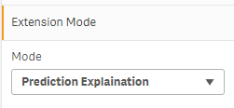

1. In the data section, select the “Prediction Key”, this should be the primary key that uniquely identifies a single row and prevents aggregation of the explanations. For the measure select “Minstring([Prediction Explanations])” if you have loaded the default column name.

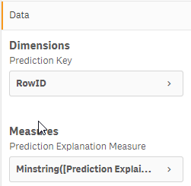

1. Typically, the extension is used to view a small number of explanations and this should be limited by selection and the calculation condition on the extension.

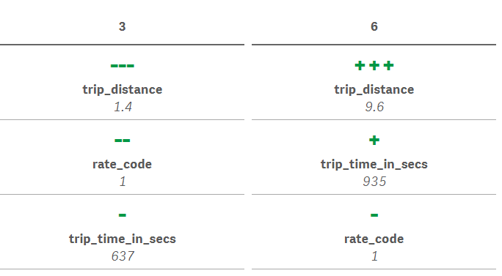

Appendix 1: Connector Specification

The Qlik2DataRobot connector uses the SSE protocol for communication. More specifically it uses the script evaluation functions to provide a more flexible framework for integration.

In the context of this connector, the “Script” expected in the SSE protocol should be a JSON message.

The JSON message specification differs based upon the value of the mandatory “request_type” object.

Base JSON message:

{

"request_type":"<REQUEST TYPE>",

"auth_config":{

"api_token":"<API TOKEN>",

"endpoint":"<API ENDPOINT>"

}

}

# Supported Request Types

## createproject

{

"request_type":"createproject",

"auth_config":{

"api_token":"<API TOKEN>",

"endpoint":"<API ENDPOINT>"

},

"project_name":"<PROJECT NAME>"

}

## Example Values:

|  |  |  |  |
| --- | --- | --- | --- |
| Parameter | Type | Required | Example |
| API TOKEN | String | Yes | SdcF4iwyv8ILjk9Nytl3e8EHkS45hUeB |
| API ENDPOINT | String (URL) | Yes | https://app.datarobot.com/api/v2 |
| PROJECT NAME | String | Yes | Data Churn Analysis |

## predictapi

{

"request_type":"predictapi",

"auth_config":{

"api_token":"<API TOKEN>",

"endpoint":"<ENDPOINT>",

"datarobot_key":"<DATAROBOT KEY>"

},

"deployment_id":"<DEPLOYMENT ID>",

"keyfield":"<KEYFIELD>",

"should_cache":<SHOULD CACHE>,

}

## Example Values:

|  |  |  |  |
| --- | --- | --- | --- |
| Parameter | Type | Required | Example |
| API TOKEN | String | Yes | SdcF4iwyv8ILjk9Nytl3e8EHkS45hUeB |
| ENDPOINT | String (URL) | Yes | https://customer.orm.datarobot.com |
| DATAROBOT KEY | String | Yes | 84e2322a-cd38-8bf3-04da-fd6f57516e21 |
| DEPLOYMENT ID | String | Yes | 5cf9abc3432eff2c75e1644f |
| KEYFIELD | String | No | RowID (NOT for use in chart expressions) |
| SHOULD CACHE | Boolean | No | true (defaults to false, only for use in chart expressions) |



**About Qlik**

Qlik is on a mission to create a data-literate world, where everyone can use data to solve their most challenging problems. Only Qlik’s end-to-end data management and analytics platform brings together all of an organization’s data from any source, enabling people at any skill level to use their curiosity to uncover new insights. Companies use Qlik to see more deeply into customer behavior, reinvent business processes, discover new revenue streams, and balance risk and reward. Qlik does business in more than 100 countries and serves over 48,000 customers around the world.

**qlik.com**

© 2018 QlikTech International AB. All rights reserved. Qlik®, Qlik Sense®, QlikView®, QlikTech®, Qlik Cloud®, Qlik DataMarket®, Qlik Analytics Platform®, Qlik NPrinting®, Qlik Connectors®, Qlik GeoAnalytics®, Qlik Core®, Associative Difference®, Lead with Data™, Qlik Data Catalyst™, Qlik Associative Big Data Index™ and the QlikTech logos are trademarks of QlikTech International AB that have been registered in one or more countries. Other marks and logos mentioned herein are trademarks or registered trademarks of their respective owners.

CODE NEEDED FOR PUBLISHING